The Wishfund savings app
As young people grow into greater independence they are faced with needing to make more important financial decisions. The temptation to borrow money at 18 creates a potential source of detriment as it becomes very easy for young people to get into unmanageable debt. An important intervention is to instill good save-and-spend behaviour as an alternative to unwise borrowing.
- Introducing the Wishfund Savings Goal app.

Introducing the Wishfund Savings Goal app.
Wishfund was created with the help of young people for young people.
It was co-created with 16-19 year olds in partnership with YoungScot, YouthNet and Storm ID.
Over a weekend workshop, a group of young people developed ideas for an app that would resonate with the target market - 16-19 year olds who may be still in a form of education, whether school, college, university, working full time, unemployed, or actively looking for work.
It’s a savvy savings app used to give young people a visual incentive to save for what they want. The objective is to encourage users to save for things they want and to ingrain good savings habits and cultivate a mentality of ‘Save, spend, then save again’.
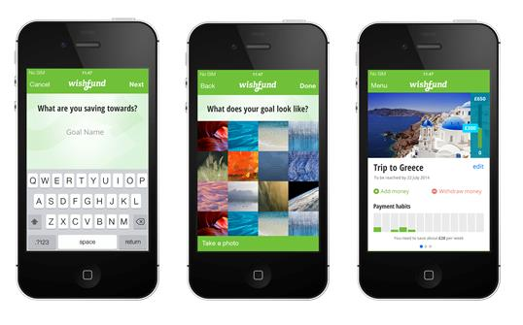
They can upload an image of whatever they are saving for, which is a motivating visual reminder of the reason to save. They can chose from a selection of different common savings goals or input their own, which can be anything they like, from a pair of the latest trainers to a to holiday with friends to Ibiza or Ayia Napa!
The app can give an indication of how long it will take to save towards the goal, based on how much and how often they save towards it.
There is also information that highlights the risks of borrowing, and things to consider do – although this page is not prominent as the goal is not to encourage.
Please take a look (its free to download on Androidand iOSopens in new window) and give it a try. Please recommend it to young people that you work with.

